Assignment 12 – Part 1

9/11 Video Discussion Questions

Video 1 - https://www.youtube.com/watch?v=1lKZqqSI9-s&list=PLhAqligcqptPZRWZSABTwHBGpv7XoGPMS&index=1

- What are your first reactions? Thoughts? Feelings? Comments?

- What do you think was going on in the minds of Americans while witnessing this?

- How do you think this moment affected/changed the United States?

Video 2 - https://www.youtube.com/watch?v=3dTsbPje_6k&list=PLhAqligcqptPZRWZSABTwHBGpv7XoGPMS&index=9

- Does President Bush’s Speech seem to express a message of fear or safety? Explain.

- How do you think this speech affected people?
  - Do you think people felt reassured after this? Why or why not?

Assignment 12 – Part 2

9/11 Oral Histories
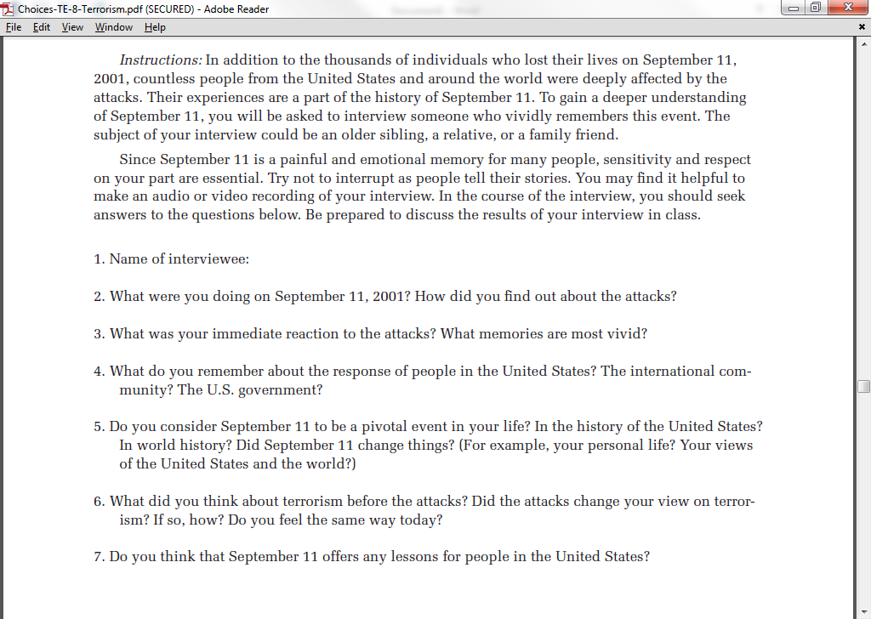
Remembering September 11

Additional Questions you may have asked them:
1.

2.

3.

